Lab Work 8. Data Visualization.
Assignment 1.
Which code can be used to obtain the following plot? (Image referenced in original worksheet.)
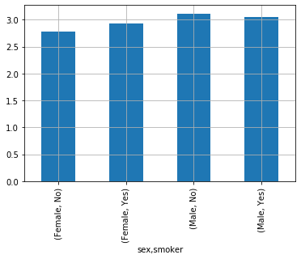
Assignment 2.
Build a distribution plot of restaurant customers who left tips, split by gender and smoking status.
Assignment 3.
Create a plot that shows the average tip amount for smokers vs non-smokers.
Assignment 4.
Write code that places an auxiliary coordinate grid as shown in the referenced figure. (Image referenced in original worksheet.)
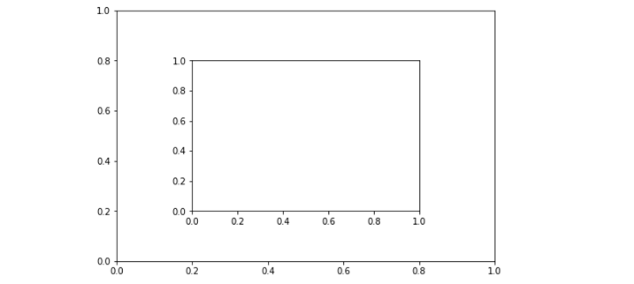
Assignment 5.
Which code can create 6 plots arranged in 2 rows and 3 columns?
Assignment 6.
Create plots in which data for smokers and non-smokers are highlighted using different colors.
Assignment 7.
Construct a plot showing the daily minimum and maximum bill amounts by day of the week.

